TERRACE COVERING WITH ROTATABLE ALUMINIUM BLADES

Manufacturer
RENSON Sunprotection-Screens NV, Kalkhoevestraat 45, 8790 Waregem – Belgium
Tel. +32(0)56 62 71 11, fax. +32 (0)56 60 28 51, info@renson.be, www.renson-outdoor.com

(You can omit the text highlighted in red according to your choice)

Description
Camargue® is an aluminium terrace covering comprising a horizontal sun protection roof, equipped with a rotatable extruded aluminium blade system, which is supported by one, two or four vertical columns, depending on the installation type. The terrace covering can be installed as a free-standing unit or against a façade.

Dimensions
Span: Minimum 1800 mm
Maximum 4500 mm
Pivot: Minimum 1800 mm
Maximum 6200 mm
Free passage height Maximum 2800 mm
Total height, without the motor box: Free passage height + 260 mm
Total height with blades in the vertical position: free passage height + 260 mm + 95 mm
Information:
The "Span side" corresponds to the span of the blades
The "Pivot side" is the side where the blades rotate (or pivot)

System implementation

Frame:
- A sturdy surrounding frame made of extruded aluminium profiles
- Height: 260 mm
- Depth of the Span frame profile: 150 mm
- Depth of the Picot frame profile: 220 mm
- Inclination: 0°

Blades:
- Sun protection blades made of extruded aluminium
- Double-walled for handling a heavy snow load
- Rotatable through 150°
- Underside: completely flat
- Upper side: sharply defined edges + water drainage gutter
- Side edges equipped with hidden fixed L-profile to stop water run-back
- The specific design ensures water drainage when the blades are closed
- And water drains off when you rotate the blades after a shower
- Blade mounting:
  - Fitting into the pivot -sides using the stainless steel shafts
  - A slight inclination on the blades for optimum water drainage

Columns:
- The installation uses 1, 2 or 4 columns, depending on the installation type.
- Dimensions: 150 x 150 mm
- Consists of a central, cross-shaped profile, finished with L-profile s that can be implemented according to custom design, using them as side channels, column lights or as limitation of rapid passage

Mounting bases:
There are 3 types:
- Visible mounting bases with a visible ground plate
- Invisible mounting bases
- Cast mounting bases

Motorisation:
- Electrical: using a 24 VDC linear motor with driving profile.
To connect to the mains voltage (230 Volt AC) through the supplied transformer.
- Placement:
  - The motors are invisibly integrated into the pivot profile

Water drainage:
- Downwards: There is a Ø 50 mm hole provided for drainage in the gutter on the edge of each pivot- side. Each hole has a drainage trap that serves as a leaf catcher and a connection for a drainpipe (Ø 50 mm)
- Sidewards: There are 2 Ø 50 mm holes provided for water drainage on the outside of the lowest pivot profile, and there is one Ø 50 mm hole provided on the other pivot profile, to which you can connect a drainpipe.

Colour:
All visible aluminium profiles are coated in your choice of architectural textured RAL colour (60-80 microns)

Assembly:
All fixings (e.g. screws) are made of stainless steel

Power supply and wiring:
Electrical cables are integrated fully and invisibly into the terrace covering

Technical data:

Maximum weight of snow load:
See the chart below, according to the dimensions
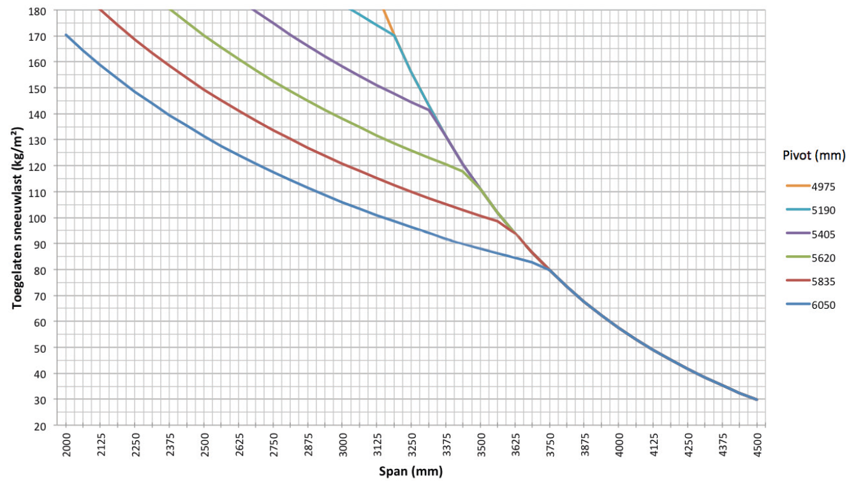

Maximum wind speed when controlling the blades:
50 km per hour

Wind resistant up to:
120 km per hour (with closed blades)

Water drainage and precipitation rate:
The terrace covering can handle precipitation rate that corresponds to a rain shower with an intensity of 0.04 L/sec/m² up to 0.05 L/sec/m², which a maximum duration of 7 minutes. This type of heavy shower occurs on average twice a year. (See the Belgian rain statistics: NBN B 52-011)

Warranty
- Five years product warranty on the structure (covering all faults that could occur during normal domestic use and when there has been regular maintenance)
- Five years warranty on Somfy®- automation
- Two years warranty on the blade motor
- Ten years warranty on the colour integrity of powder coating on the aluminium profiles
- Five years warranty on gloss (powder coating )

Options

Up/Down LED lighting:
Integrated LED lighting along the full length of the inner side of the frame equipped with Upwards and/or Downwards lighting
- Up:
  - Warm white light, 120 LEDs/m | +/- 2800 K | 550-680 lumens/m
  - Pure white light, 120 LEDs/m | +/- 5000 K | 550-680 lumens/m
- Down:
  - Warm white light, 120 LEDs/m | +/- 2800 K | 550-680 lumens/m
  - Pure white light, 120 LEDs/m | +/- 5000 K | 550-680 lumens/m
  - RGB 60 LEDs/m | 550-700 lumens/m

Loggia sliding panels
- Loggia sliding panels comprise 40 x 40, 40 x 55 or 40 x 70 mm powder coated aluminium frames, depending on the passage height. The 40 mm side is always facing towards the front
- This frame is filled in with:
  - Square, aluminium, fixed blades
  - Square, aluminium, rotatable blades
  - Square, Western Cedar, fixed blades
  - Square, Western Cedar, rotatable blades
  - Glass fibre screen fabric
- The sliding panels are suspended in aluminium upper rails and slide in an aluminium bottom rail
- Operation is manual
- The system can handle height differences of up to 5 cm, using a flexible lower guide system
- See the specification text for Loggia sliding panels for a detailed product description

Integrated Fixscreens
- It is possible to integrate vertical sun protection fabric screens in the terrace coverings with a passage height ≤ 2.8 m
- The frame profiles of the basic structure also form the box for the overhead sun protection
- The side channels are made of extruded aluminium They are 3-piece
- The stepped shape in both components allows you to screw the side channels easily and in the proper manner onto the columns
- See the specification text for Fixscreens for a detailed product description

Glass wall
- You can build glass sliding panels into terrace coverings with up to 2600 mm passage height
- The glass profiles are made of powder-coated extruded aluminium
- The control is manual
- The glass sliding panels are supported at the bottom by an extruded aluminium rail that is finished with a corrosion resistant guide channel
- The glass is 10 mm thick safety-glass
- You can close the glass wall securely using a lock that you can open and close with a key from either side.

Beam:
- You can equip the terrace covering with a Beam-
module, an aluminium housing that can house a heating element (Heat) and loudspeakers (Sound).
- Mountable on the inner side of the frame profile on the Span-side
- You can swing the module (stepless) through 30° for adjustment

Heat:
- A heating element that you can integrate in the Beam-module
- The visible, corrugated plate is anodised in black
- Convection heat
- Power: 2600 W/Heat, Power rating = 12 A/Heat
- IP 65
- RTS control (exclusive receiver, remote and controls)

Sound:
- "Flat Panel" type speakers that integrate into the Beam-module
- "Plane Wave" technology
- 25 W RMS, Flat Panel Speaker
- 50 W peak capacity, Flat Panel Speaker
- IP 65
- Connection: Connects to a tuner/amplifier using an audio cable

Rain sensor kit:
- Capacity: Rain sensor, mounting materials and accessories
- Action:
  - Closes the blades automatically when there is rain
  - Rotates the blades to their pre-set snow position whenever there is precipitation combined with a freezing temperature
- It is mounted on a slight incline and has a tiny heating element for better sensor drying

Wind sensor kit:
- Capacity: Somfy Eolis RTS Wind sensor and extra accessories
- Action: The blades should be closed when wind speeds are > 50 km/hour, to conform to our warranty terms
- The wind sensor has priority over the rain sensor

Norms
This product is made to conform to, satisfies and/or has been tested according to the norm: EN 13561

